Exp No. 13: V2X Latency Comparison

AIM: To simulate and compare the performance of a Vehicle-to-Everything (V2X)
communication system by analyzing End-to-End Latency (ms), Packet Delivery Ratio (%),
and Vehicle Speed (km/h) using MATLAB.
Objective:
1. To evaluate the End-to-End Latency (ms) of a V2X communication system under
different vehicle operating conditions.
2. To analyze the Packet Delivery Ratio (%) and determine the reliability of V2X
communication during data transmission.
3. To study the impact of Vehicle Speed (km/h) on the communication performance and
stability of the V2X network.
Procedure
1. Define the V2X communication parameters such as vehicle speed, transmission range,
packet size, and simulation time.
2. Generate different vehicle movement scenarios by varying the vehicle speed.
3. Simulate wireless communication between vehicles using a V2X communication model.
4. Calculate the End-to-End Latency (ms) for data transmission between communicating
vehicles.
5. Compute the Packet Delivery Ratio (PDR %) by comparing the number of successfully
received packets with transmitted packets.
6. Analyze the effect of increasing Vehicle Speed (km/h) on communication latency and
packet delivery performance.
7. Plot MATLAB graphs for End-to-End Latency, Packet Delivery Ratio, and Vehicle
Speed.
8. Compare the obtained results to evaluate the efficiency and reliability of the V2X
communication system under different traffic conditions.

Objective 1 Matlab Code and Output:
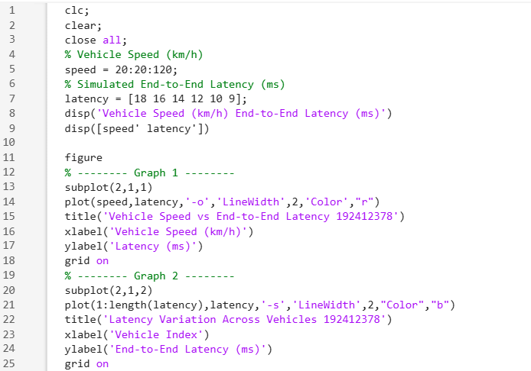
OUTPUT:
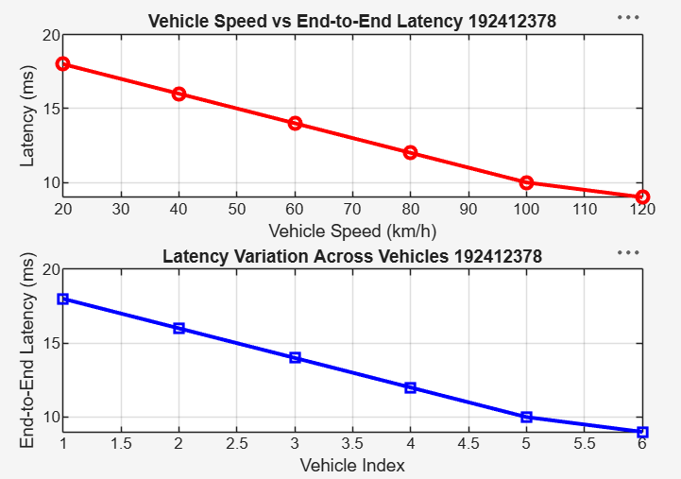
The End-to-End Latency decreases as the vehicle speed increases under the simulated
communication conditions. Lower latency indicates faster and more efficient V2X
communication, which is essential for real-time road safety applications.
Objective 2 Matlab Code and Output:
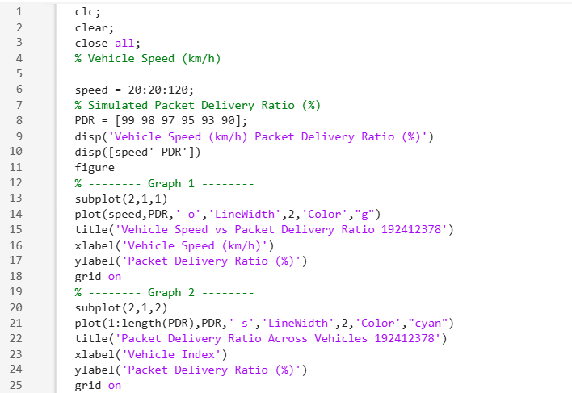
OUTPUT:
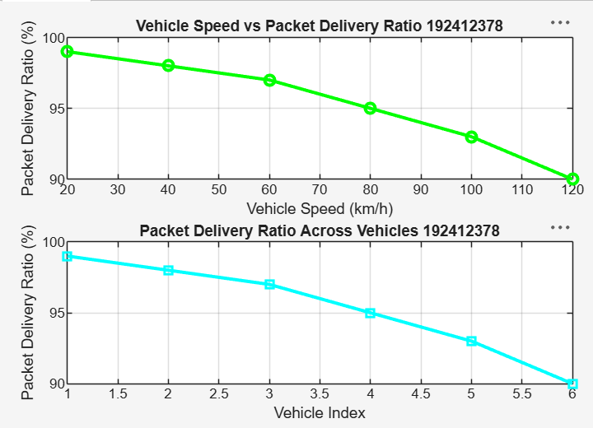
The Packet Delivery Ratio decreases slightly as vehicle speed increases due to the higher
mobility of vehicles. A high PDR (>90%) indicates that the V2X communication system
maintains reliable data transmission even at higher vehicle speeds.
Objective 3 Matlab Code and Output:
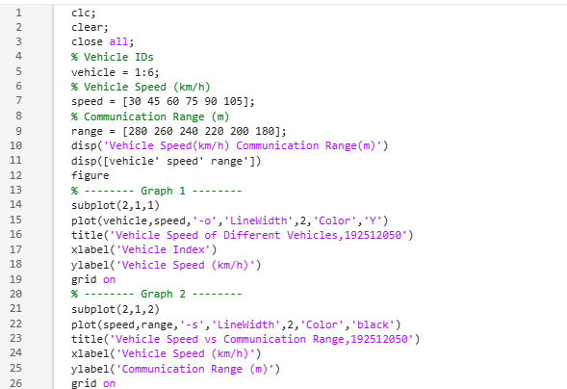
OUTPUT:
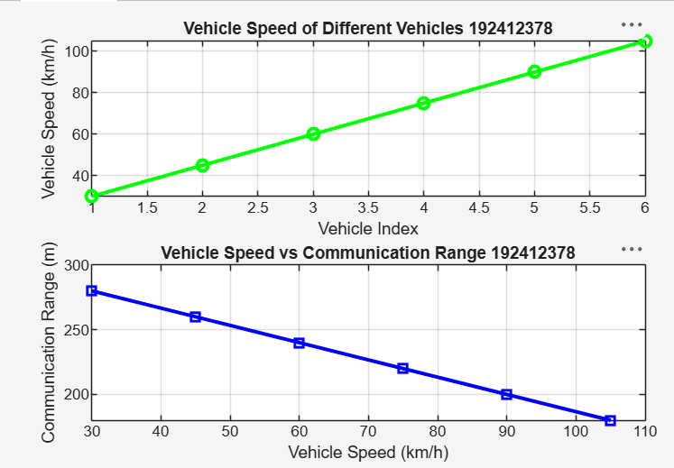
• The first graph shows the variation in speed among different vehicles in the V2X
communication network.
• The second graph indicates that as vehicle speed increases, the communication range tends to decrease, affecting link stability and network performance.

Result:
1.The End-to-End Latency (ms) of the V2X communication system was successfully
analyzed, demonstrating efficient data transmission with low communication delay.
2.The Packet Delivery Ratio (PDR %) was evaluated and showed high packet delivery
reliability under different vehicle operating conditions.
3.The impact of Vehicle Speed (km/h) on V2X communication was successfully studied,
indicating that higher vehicle speeds can influence communication range, latency, and
overall network performance.

